UPDATE IN AN ARRAY:

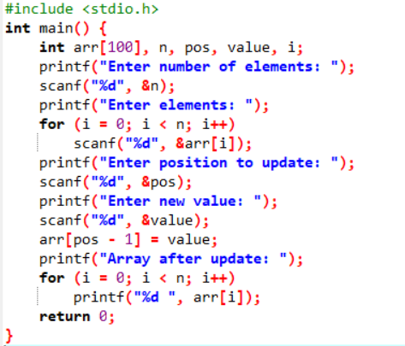\

OUTPUT:

